1. Download folder from “Word Counter”

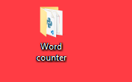

1. Go back to folder “Word counter” and enter cmd in directory way

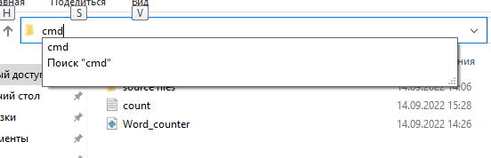

1. Pressed enter
2. In console write “python Word_counter.py”

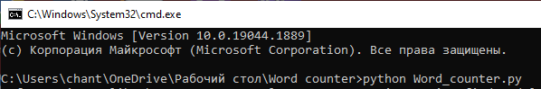

1. After you need to follow the instructions from the program.